**School Management System Process**

**Course: Business Process Engineering**

**Presented To:**

**Dr. Abdul Aziz**

**By:**

**Salman Ahmed Khan (19K-1043)**

**Sadeem Sattar (19K-1102)**

**Abdullah Tilal Khan (19K-1103)**

**Dated: 29 May 2022**

**Introduction**

The software School Management System is designed to facilitate the work of school management.

The management system will provide ease to maintain the record of students and teachers.

It will provide the day-to-day automated functionality of school management.

**Business Model Hierarchy**

Below is the attached hierarchy of the business process.

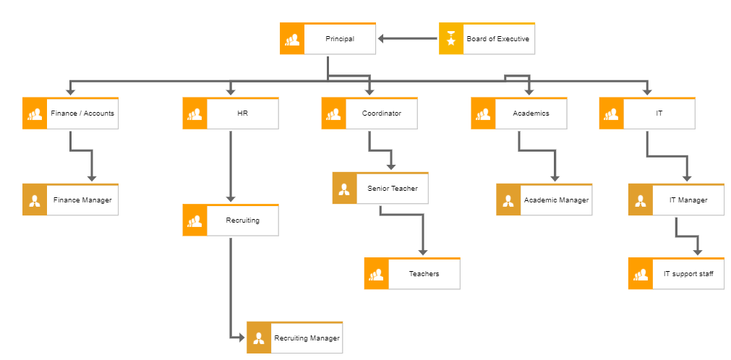

Figure - School Organization Hierarchy

**School Organization Process**

The school organization process contains three major processes including Management Process, Core Process and Supporting Process.

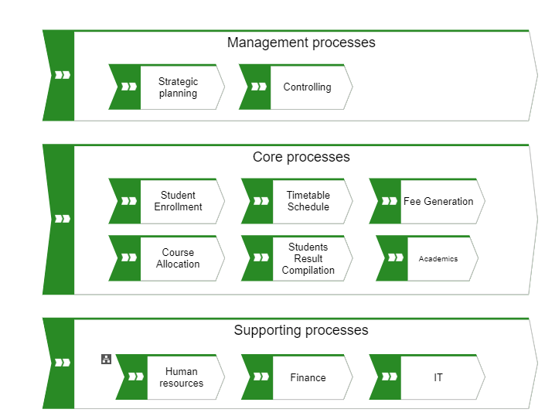

Figure - School Organization Processes

**School Organization Current Student Enrollment Process**

The current student enrollment/registration process is a tedious and time taking process. It requires a student to fill its form, attach documents and then wait for the School Principal to sign the form to complete the registration process. However, this can be done through Academic Manager.

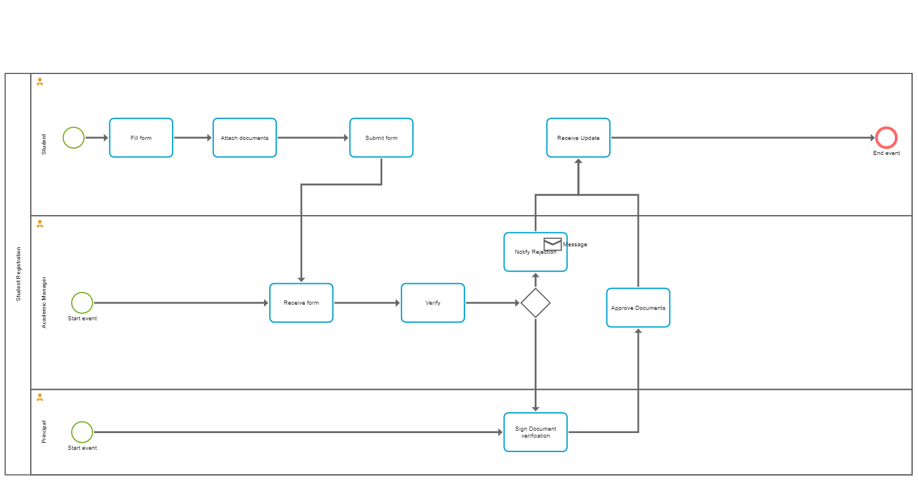

Figure - Student Registration Process (Current)

**School Organization Proposed Student Enrollment Process**

The proposed solution eliminates the school principal form signature process as it is irrelevant process and the documents and form can be verified by the Academic Manager only.

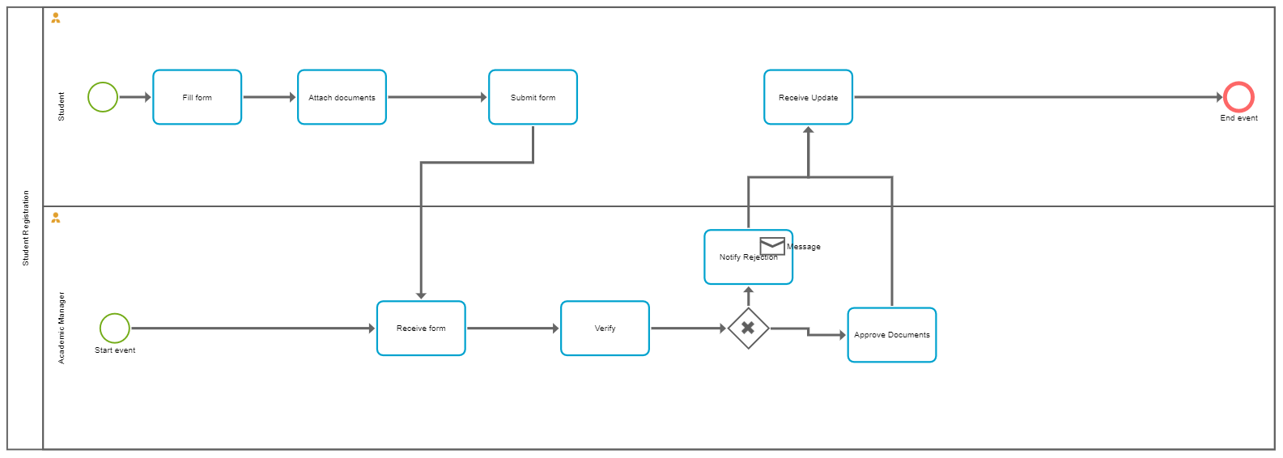

Figure - Student Registration Process (Proposed)

**School Organization Enrollment Event Process**

The below is the attached event process of the student enrollment events.

